Academic History:
- B.S. Physics, Villanova University (1969)
- M.S. Physics, State University of New York at Albany (1977)
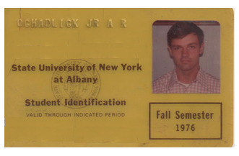

- Ph.D. Physics, State University of New York at Albany (1980)
- Physics Lab/Lecturer, State University of New York at Albany (1977-1979)
- Physics Research Professor, U.S. Naval Postgraduate School (1982-1983)
- Visiting Scholar, University of Pennsylvania (1991-1996)
